



Annual Report 2026
Charity No: Excepted Charity
HQ Registration Number: (15822) S10001663
HMRC Registration: XR76125
Bankers: Lloyds / Hampshire Trust Savings
Custodian Trustees: The Scout Association Trust Corporation
Period - 01 April 2025 – 31st March 2026
Constitution/Governing Document: As Set out in POR https://www.scouts.org.uk/por/

Date: July 4th 2026 16:00
Venue and Principal Address: Dudley District HQ, Swindon Road, DY6 0AW


AGENDA

- Introduction and welcome
- Apologies for absence
- Governance topics
- Approve the minutes of the Annual General Meeting held on 28/6/2025
- Adopt the model constitution from Policy, Organisation and Rules (POR)
  - https://www.scouts.org.uk/por/5-local-governance-and-finance-of-groups-districts-counties/#5.5
- Note the District’s financial year
- Agree 9 members that may be appointed to the Trustee Board
- Reaffirm the quorum for future meetings of the District Scout Council
- Review of the previous year
- The District Lead Volunteer’s review of Scouts in Dudley District – See Attached
- Receive and consider the Annual Report of the District Trustee Board, including the annual Statement of the Accounts
- Making appointments
- Appoint the District Chair, Appoint the District Treasurer and Appoint members of the District Trustee Board, there were no vacancies arising as part of the new constitution and HQ Recommendations – Future appointments will be following recommendations from the open selection process initiated by the District Trustee Board
  - Chair - Kerry Bullock
  - Treasurer - Chris Soper
  - Trustee Board Members - Chris McEwan, Rachel Wilson, Fran Sedgley, Alan Chadwick, Dave Tyler, Bob Fellows, Ted Batham, Myla Haywood
- Appoint District President
    - Dave Tyler
- Appoint the Scrutineer
    - Neal and Co
- Nominate representatives of the District Scout Council to represent the District on the County Scout Council
    - Fran Sedgley and Dave Tyler
- Closing remarks
3A - DUDLEY DISTRICT SCOUTS
DISTRICT AGM
28TH JUNE 2025
DISTRICT HEADQUARTERS

- Introduction and welcome

Chair – Kerry Bullock opened the meeting with a warm welcome to all present.
A moments silence was held for us to remember Scouters who served in the district who have “gone home” since our last AGM

- Apologies for absence

The Chair confirmed a number of apologies had been received for their absence today.

- Governance Topics

The chair confirmed that this was the part of the meeting that ensures our Charity foundations are in good order
3a The minutes of the AGM held on 28/6/2025 and distributed with the AGM papers for this meeting were put forward as a true record of that meeting.
Seconded by Chris McEwan and a show of hands accepted the minutes.

3b In line with the recommendations from HQ, the District Trustee Board proposes we renew for this year the model constitution (Chapter 5 of P.O.R.)
A significant show of hands confirmed approval.

3c Financial Year for the District was advised as being 1st April to 31st March

3d The Trustee Board proposed that 9 people are appointed to the Board in line with recommendations from Charity Governance Code and POR.
A significant show of hands confirmed approval.

3e The Trustee Board proposed that 25 people (approximately 10% of District membership) should be set as the quorum.
A significant show of hands confirmed approval.

4 Review of the Previous Year
4a DLV Ted Batham introduced the Annual Statement which had previously been circulated.
4b Treasurer Chris Soper introduced and explained the Financial Statement which had previously been circulated
5 Making Appointments
5a District Trustee Board – The chair thanked all members of the Trustee Board for their contributions during the past year and confirmed the following appointments for 2025/26
Chair – Kerry Bullock
Treasurer – Chris Soper
Trustees - Chris McEwan, Rachel Wilson, Fran Sedgley, Alan Chadwick, Dave Tyler, Bob Fellows and Ted Batham
5b The chair proposed the appointment of Bob Heeley as District Vice President A significant show of hands confirmed approval.

5c The Chair proposed Neal and Co as appointed scrutineers/Independent Examiner/Auditor for the District. A significant show of hands confirmed the approval.

5d The chair proposed Dave Tyler and Fran Sedgley as the nominated representatives for Dudley District on the County Scout Council. A significant show of hands confirmed approval.

6 Closing Remarks
The meeting closed with a “Thank You” from both the Chair Kerry Bullock and DLV Ted Batham for another very successful scouting year in Dudley District. Everyone was invited to refresh drinks before moving on to the Award presentation part of the meeting. A full copy of all award recipients had been circulated with AGM report .
Meeting closed 2.45pm

Objectives, Structure Governance and Management
Summary of the purpose and objects of the charity as set out in its governing document | The objectives of the charity are as a part of The Scout Association.  The Purpose of Scouting  Scouting exists to actively engage and support young people in their personal development, empowering them to make a positive contribution to society.  The Values of Scouting  As Scouts we are guided by these values  Integrity – We act with integrity; we are honest, trustworthy and loyal  Respect – We have self-respect and respect for others  Care – We support others and take care of the world in which we live  Belief - We explore our faiths, beliefs and attitudes  Co-operation – We make a positive difference; we co-operate with others and make friends  The Scout Method  Scouting takes place when young people, in partnership with adults, work together based on the values of scouting and:  - enjoy what they are doing and have fun  - take part in activities indoors and outdoors  - learn by doing  - share in spiritual reflection  - take responsibility and make choices  - undertake new and challenging activities  - make and live by their promise
Statement confirming the trustees have had regard to the guidance issued by the Charity Commission on public benefit | The Trustees confirm that the charity meets the Charity Commission’s Public Benefit criteria under both the advancement of education and the advancement of citizenship or community development headings.
Type of governing document | The charity’s governing documents are those of The Scout Association. They consist of a Royal Charter, which in turn gives authority to the Bye Laws of the Association and The Policy Organisation and Rules (POR) of The Scout Association.
How the charity is constituted | The charity is a trust established under its rules which are common to all Scouts. It is constituted as an educational charity.
Trustee selection methods | The Trustees are appointed in accordance with the Policy Organisation and Rules of The Scout Association. We have an open and transparent process for the recruitment of new trustees when required.
Policies and procedures for the induction and training of trustees | All Trustees complete The Scout Association trustee and mandatory learning within the first six months of joining the Trustee Board, they also complete other Scout Association mandatory learning periodically as required.
Additional governance arrangements | The charity is managed by the Trustee Board, the members of which are the “Charity Trustees”. As charity trustees they are responsible for complying with legislation applicable to charities. This includes the registration, keeping proper accounts and making returns to the Charity Commission as appropriate.  The Trustee Board consists of the Chair, Treasurer and minimum of 5 trustees and meets a minimum of 3 times a year. The Trustee Board is supported by a Board Administrator.  The Trustee Board exists to support the District Leadership Teams in meeting the responsibilities of their appointments and in supporting them to run high-quality and safe programs that give young people skills for life. The Trustee Board maintain appropriate governance policies and oversight.  The Trustee Board is responsible for carrying out its purposes for the public benefit, complying with the charity’s governing document and the law, and managing the charity’s resources responsibly.  The Trustee Board is responsible for ensuring the charity is well managed, risks are assessed and mitigated, buildings and equipment are in good order and everyone follows legal requirements and Scout Association Policy, Organisation & Rules.  This includes responsibility for:  - Promoting a positive image of Scouting in the community, as well as its development;  - Developing, maintaining and regularly a risk register, including putting in place appropriate mitigations;  - Ensuring that the finances are properly managed, and there are sufficient resources (and reserves) to deliver high quality Scouting;  - Ensuring a system of internal controls is in place that is designed to provide reasonable assurance against material mismanagement or loss;  - Ensuring that property is appropriately managed;  - Maintaining appropriate insurance of persons, property and equipment;  - Assisting in the recruitment of leaders and other adult support;  - Having an open and transparent selection process for the recruitment of Trustees;  - Appointing Advisors as required;  - Ensuring effective administration is in place to support the Trustee Board;  - Ensuring compliance with applicable governance and charity regulations, including in respect to safety and safeguarding;  - Ensuring incidents are appropriately reported in line with regulation and policy;  - Ensuring applicable policies and regulations are regularly reviewed and changes implemented as appropriate;  - Ensuring transparency of operations, including in the preparation of accounts and holding and AGM;  - Ensuring compliance with Data Protection legislation;  - Acting as a responsible employer for any employees, who are effectively managed.
Operational review of Activities and Achievements – District Lead Volunteer – Ted Batham
Summary of the main activities in relation to the purpose and objects
During the year, Dudley District Scouts continued to deliver high-quality Scouting to almost 900 young people and support more than 300+ adult volunteers across 16 Scout Groups, Explorer Units, and Scout Network. The district acted as a governance, training, and operational hub, enabling local groups to thrive and ensuring consistent programme quality across the borough.
Key activities included:
- Programme support for Squirrels, Beavers, Cubs, Scouts, Explorers, and Network
- District-wide events including St George’s Day Parade, Explorer skills days, and 2025 District Camp
- Volunteer training and compliance support, including safeguarding, safety, and mandatory learning
- Governance support for group AGMs, trustee recruitment, and Charity Commission compliance
- Financial inclusion initiatives, ensuring no young person was excluded due to cost
- Environmental sustainability work, including solar-powered HQ operations and recycling programmes
- Community partnerships with Dudley Council, local schools, Russells Hall Hospital, and borough charities
- Digital infrastructure, including Office 365, shared risk assessment tools, and district-wide communications systems
- Equipment provision, including pioneering poles, marquees, PA systems, and shared camping resources
- Support for international Scouting, including Jamboree and Kandersteg preparation and funding
These activities directly reflect the Scout Method and the purpose of Scouting, enabling young people to develop skills for life.

The 2025–26 year was one of consolidation, growth, and renewed strategic focus. Key achievements include:
1. Supporting almost 900 young people and 300+ volunteers
The district maintained strong youth membership and volunteer engagement across all 16 groups, with Explorer and Network sections operating most weeknights and offering a rich, inclusive programme.
2. Strengthening District volunteer leadership
- 20-person Leadership Team and many Support Teams maintained operational resilience
- Structured recognition through long-service awards and public acknowledgements
- Flexible volunteering models and wellbeing support
3. Major community impact
- St George’s Day Parade engaging 600+ young people
- Renewed partnership with Russells Hall Hospital delivering activities on the children’s ward
- District-wide recruitment campaigns through Dudley CVS and local schools
- Civic engagement through events at Dudley High Street, BCLM, and Dudley Zoo
4. Sustainability and environmental leadership
- Solar-powered HQ reducing carbon footprint
- Recycling stations at HQ and events
- Uniform donation and renovation scheme
- Equipment repair and reuse through the Explorer workshop
5. Skills development and youth leadership
- 50+ Explorers trained in First Aid
- 20+ DofE participants supporting sections
- 70% retention of DofE volunteers into Young Leader or adult roles
- 1424 - Explorer-led equipment store
6. District HQ as a hub for growth
- Training centre hosting adult learning and youth skills sessions
- Wi-Fi and conferencing enabling hybrid meetings
- Field access supporting outdoor learning for groups lacking green space
7. Equipment investment and shared resources
- District-wide pioneering poles
- Marquees, shelters, PA systems
- Camping equipment for DofE and Explorer expeditions
- District activity equipment at the HQ
8. Strategic development
The district began a structured review of its long-term strategy, aligning with the national Strategy to 2035 and preparing for a leadership refocus meeting to address challenges and future growth.
Achievements against objectives
The district met or exceeded its objectives in programme quality, volunteer support, governance compliance, and community engagement.
Fundraising activities
- District Shop income
- New Year Fireworks fundraising event
- Recycling and uniform donation scheme
- International event fundraising
Contribution made by volunteers
The district’s 300+ volunteers contributed thousands of hours across leadership, governance, training, maintenance, and event delivery. Their commitment remains the backbone of the charity’s success.
The principal risks identified during the year include:
- Volunteer recruitment and retention, mitigated through flexible roles and targeted recruitment
- Financial sustainability, mitigated through diversified fundraising and prudent budgeting
- Compliance risks (safeguarding, safety, data protection), mitigated through mandatory training and regular policy review
- Property and equipment risks, mitigated through maintenance schedules and insurance
- Youth inclusion barriers, mitigated through hardship funding and uniform recycling
Plans for Future Periods
The district’s plans for 2026–27 and beyond align with the Strategy to 2035 and include:
- Strengthening volunteer pipelines through Dudley CVS, schools, and YouWM
- Establishing new sections in underserved areas
- Expanding Explorer and Network provision
- Increasing environmental sustainability across all operations
- Enhancing digital cohesion and shared systems
- Growing community partnerships with local charities, schools, and the council
- Delivering the next District Camp and expanding district-wide events
- Increasing financial inclusion and hardship support
- Continuing HQ development as a training and community hub

District Team
District Leadership Team – Team Lead – Ted Bathams points of Note at Group Level
3rd Sedgley – GLV Dean Stanford – Jenny stepped down mid period and after a selection process Dean was appointed – The group is stable and moving forward positively.
1st Netherton – GLV Vacant – Sadly still without Beaver Section, but the Trustees are working to Address the building. The Trails of a new beaver section and recruitment drive haven’t yielded results as of yet – but we will continue to support and move forward. Cubs and Scouts are Stable.
7th Dudley – GLV Darren Robinson - The group is stable and moving forward positively.
1st Quarry Bank – GLV Richard Jinks - The group is stable and moving forward positively. Sadly, lost their Squirrel Section due to adult numbers.
1st Gornal – GLV Michelle Holding - The group is stable and moving forward positively follow a few periods of uncertainty over the past few years.
2nd Lower Gornal – GLV Suzanne Jones – The group is stable and moving forward positively.
1st Wall Heath – GLV Ant Mullen - The group is stable and moving forward positively.
1st Sedgley – GLV Ian Foster – Mandy Stepped down Mid Period and after a selection process Ian is now confirmed in post - The group is stable and moving forward positively.
3rd Brierley Hill – GLV Adrian Pargeter – Adrians Stepped down at the end of the period and will be replaced by Ed Godwin. Thank Adrian for all his work over the years and getting the group to a stable position with a whole new team of adults.
1st Russells Hall Hospital Group – GLV Mandy Todd – Mandy offered to help and has built a team and is working with the hospital to resume regular sessions after a break from the trials of last year.
1st Coseley – GLV Vacant – The Group has challenges with adults, but a stable team has presented itself over the past 12-18 months and with sections running well and a trustee board, looking to fill the GLV is the last hurdle.
1st Kingswinford – GLV Dawn Rides - The group is stable and moving forward positively.
2nd Kingswinford – GLV Paul Cartwright – The group continues to have challenges with adults, but is stable and doing better than the previous year.
3rd Kingswinford – GLV Kaye Sheppard - The group is stable and moving forward positively.
1st Wordsley – GLV Jon Whitehouse - The group is stable and moving forward positively.
2nd Wordsley (Holy Trinity) – GLV Sam Beach - The group is stable and moving forward positively.

District 14-24 – Team Lead – Rachel Wilson


I can’t believe another year has passed us!
It’s been another great year for Team 14-25. We are continuing to run 3 very successfully units all with strong numbers of young people attending, and have continued to work hard together as a team to provide the young people of the Team 14-25 age range a fantastic experience during their time with us.
What have we been up to?
- As you all know we attended the district camp to Blackwell Court where the Explorers enjoyed the luxury of the camping pods. They carried out lots of activities and finished the camp with a lovely cool down in the pool.

- We have been again meeting throughout the year to continue the day hikes as a District.

- In September the district went to Cornel Scout Centre in Wales, for what turned out to be the wettest camp ever!
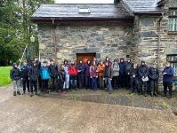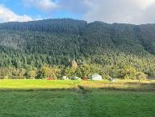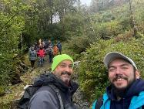
With a visit to Conwy Castle on the way home, thankfully the weather was better!
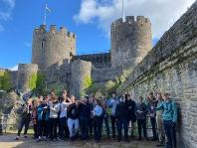

- In March we had several of the Explorers, Network and leaders take part in the Chase Walk. Some of whom managed to complete the walk, which is an excellent achievement!
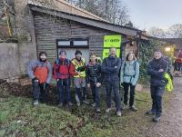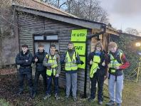

- In April, some of the Dudley district Explorer’s attended the St Gorges day celebrations at Black Country Museum.

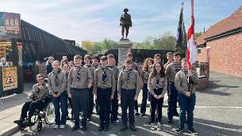

- South Explorer unit ran a night Hawks evening, where they invited all their feeder Scout groups. This was a great way for leaders and young people to get to know each other and help with the transition to Explores from Scout. We hope to run more events like this over the next year for all of our Scout groups to enjoy.
This is just the snap shot of what has been taking place around the District.
DofE
The DofE group has been very active over the last 12 months. A number of practice walks and bronze DofE has taken place. The group is growing which is great and we will soon be seeing lots more Explorers gain bronze award.
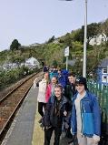
Network Update:
Network has been a big challenge over the last 12 months, we do have a small group who have been trying to get things off the ground. They have a plan for the next 12 months so what this space!
Kandersteg:
The team have been working hard to get everything in place for their trip to Kandersteg in July. They have had some successful fundraiser events, including a quiz night, curry night and the bonfire.
The group are all very excited about the trip and we cant wait to hear how they get on.
I would like to say a big thankyou to all the Dudley District Explorer leaders for the time and effort that they all give to the young people within the units and for giving up lots of their time to provide the great activities for them.
Finally, I would also like to say a huge thankyou to Ted and the rest of the District team for their continuous support throughout the past year.
As I always say here’s to the next 12 months.
Trustee Board – Chair – Kerry Bullock
Thank you for all attending today, I would like to thank all my fellow trustees for their commitment and diligence during the year. We are continuing to look at developing further income revenues for the district in the coming year and to promote access and use of the HQ building and develop further activities to attract more groups to use the building more regularly. The Easter Raffle is now in its fourth year and that it brings in a valuable contribution to both Groups and District. We have also opened the District Uniform shop, which we hope to develop over the coming months and years, by selling new and used uniforms for all groups and we hope to promote the shop through the groups letting parents know that there is an alternative to buying online.
All the Trustees for the District are working towards making the district more effective, responsive and efficient as it can be, and I thank them again for all their hard work.
Finally, a big thank you to all the Leaders, Helpers and Volunteers who without them Scouting would not be able to continue in Dudley District.

District Youth Lead – Myla Haywood
Over the past 12 months, as Youth Lead, I have started to plan for activities & new ideas to bring to Dudley District; with the plan to be to start a lot of these activities / opportunities aver the next 12 months. We are hoping to start a Dudley District Youth Forum at the end of 2026, this will give young people the opportunity to voice their opinions on district activities such as St George's Day and camps. We also hope to help support more young leaders to complete their non-compulsory modules and missions allowing them to gain their Young Leader Qualification.
More information to follow to leaders about the youth form in the next couple of months, as we hope to get as many young people involved as possible.
Volunteer Development Team – Team Lead – Chris Haywood
Over the past year, Volunteer Development within Dudley District has continued to focus on supporting, retaining, and growing a strong and capable volunteer team across all sections.
We have made some positive progress in helping new volunteers get started more effectively, providing guidance through induction, learning requirements, and early engagement with their teams. Ensuring volunteers feel welcomed and supported from the outset remains a key priority, helping to build confidence and long-term commitment.
Support has also been provided to existing volunteers to develop their skills and take on new challenges within their roles. This includes encouraging participation in training, promoting good practice, and helping individuals identify personal development opportunities aligned with both their interests and the needs of the district.
Volunteer wellbeing has remained an important focus. We have encouraged open communication and worked with Group and District teams to ensure volunteers feel valued and supported in their roles, recognising the significant contribution they make to delivering scouting locally.
I have engaged with fellow Volunteer Development team members across the County, sharing good practice and building relationships that will help strengthen our approach moving forward. This collaboration will continue into the new year and beyond.
From late 2026, I will be dedicating more time to developing the Volunteer Development role within the District. This will allow for a greater focus on improving processes, strengthening support for volunteers, and enhancing recruitment and retention activities.
Our future priorities will include:
• Strengthening recruitment to ensure sustainable growth across all sections
• Continuing to improve the volunteer journey from enquiry through to full involvement
• Increasing engagement with learning and development opportunities
• Supporting leaders to deliver high-quality programmes for young people

Overall, the dedication and commitment of our volunteers across Dudley District remain a key strength, and I would like to thank everyone for their continued hard work and enthusiasm over the past year.
Programme Team – Team Lead – Fran Sedgley
We held our first district camp for many years at Blackwell Court. Each youngster had 5 activities over the weekend. Due to the extreme dry period, we were unable to hold our planned camp fire. It was enjoyed by all. My thanks to the team that planned and organised it all.
Thanks also to the team that organised our St George's day at Dudley Zoo. We were able to line up by the flamingos and March up to castle and renew our promise. Families were then able to spend the rest of the day in the Zoo.
We also had a circus skills day at our HQ for Beavers and Cubs. Everyone had a great time. Again, thanks to the very small team that put this together
Support Team – Team Lead – Dave Tyler
Fundraising Team - District Raffle - the District Raffle continues to be a major source of revenue in our fundraising armoury with proceeds being split between District and Groups. District sources the prizes, complies with all legal requirements and runs the raffle and Groups distribute tickets for sale to their Scouting community and create a steady income stream each year. Thanks again to Chris McEwan for her hard work in organising the event and sourcing prizes with over £5,400 being raised this year. We are always looking for good quality raffle prizes and, of course main and junior sponsorship to allow us to direct more funds to Groups. If you know of any Company willing to be a sponsor, please let us know, it’s all good PR for a local company to be involved in supporting the community, especially Scouting.
District HQ Team - Once again, our thanks go out to Chad and our HQ Team for all the hard work, commitment and enthusiasm in keeping our District HQ safe and fit for use. In our last report we highlighted our installation of solar panels, and we are pleased to see that initiative paying dividends, both financially and environmentally.
This last year has seen us install an Alarm, CCTV and Smoke Detectors to our HQ buildings on site using ultra -modern technology. We continue to make our HQ and site a safe place for all to enjoy.
HQ Activities - Pioneering, Towers of Hanoi & Chess Board. - We are pleased to report that our pioneering poles are being used more and more and we are hoping to put on some training for Leaders and Youngsters who may see pioneering as a ‘dark art’ but in reality, is an engineering skill, something our youngsters would be able to add to their CV’s when attending job interviews. Not many youngsters will be able to make that claim but Dudley is leading the way on pioneering.
Our recent Towers of Hanoi tyre logic puzzle is now installed with different sized tyres making up the tower. It will take 31 moves to complete the puzzle with our 5 tyres.
Our Chess board is nearing completion, and our oversized chess pieces are available on site.
We are always looking for different activities on site and would welcome any suggestions.
District Phone - Phone calls continue to be made to our District Phone 0300 365001 when parents ask about vacancies for their children. Those calls are passed on without delay and today is a timely reminder to us all how important it is to respond as soon as we can to any enquiries.
District Shop - Our District Shop is now up and running and sales are steadily increasing with Kerry Bullock at the helm on Saturday mornings. Please feel free to talk to Kerry at the AGM about stock, pre-worn uniform and all things Scout Shop. There is no other source for Scouting goods except via HQ Scout Shops which incur postage.

Financial Review and 2025 -26 Accounts – Treasurer – Chris Soper:
Reserves/Investment/Grants and other Relevant Policies: https://www.dudleyscouts.org.uk/home/charity-governance
Following an Annual Budget.
Over the 2025/26 financial year, the District’s income increased significantly from £83K in 2024/25 to £141K in 2025/26. This uplift reflects the growth in the scale of events we have been able to deliver, alongside improved participation in Explorer scouts. Our increased income now places us above the threshold requiring formal registration with the Charity Commission. As a result, we will be progressing with registration as a charity during the coming year. This is a positive and necessary step that will provide greater transparency, strengthen governance, and support our continued growth. It also ensures we remain fully compliant with regulatory requirements.
In addition to event related income, we generated £741 from our solar installation, which was donated to us in 2024 by Insolation Solar. This now provides a helpful contribution towards offsetting our electricity costs. This is a modest but meaningful step in reducing our operating expenses and improving long term sustainability.
During the year, we also suffered a break in to the storage containers. While this was a disruptive and unwelcome incident, it resulted in a successful insurance claim, ensuring that the financial impact on the Group was minimised and that essential equipment can be replaced without detriment to our core activities. As part of this claim our trustees have committed to undertaking a full inventory of items we own during 2026/27 this will update our total valuation on the financial statement once completed on our accounts next year.
We have recently opened a new investment account with Hampshire Trust Bank PLC, providing a secure and more effective way to manage our reserves, to maximise our income.
Overall, the District remains in a stable financial position, with income growth enabling us to reinvest in programme delivery, equipment, training, and facilities. I would like to thank all volunteers involved in organising and supporting events throughout the year—their efforts have been central to achieving this level of financial performance.

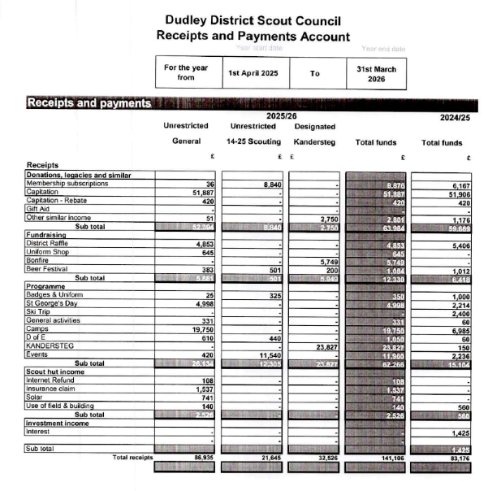

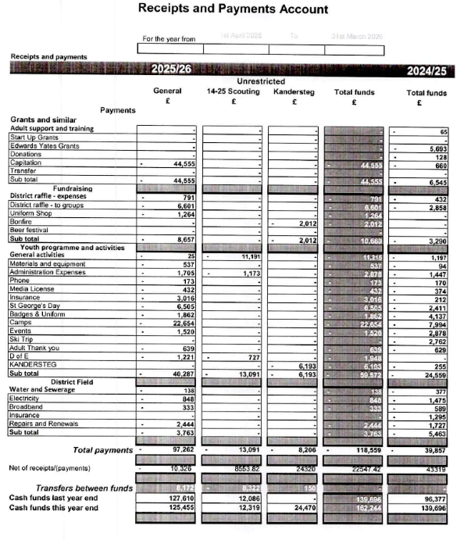

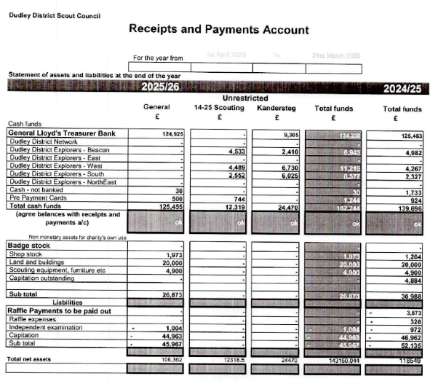

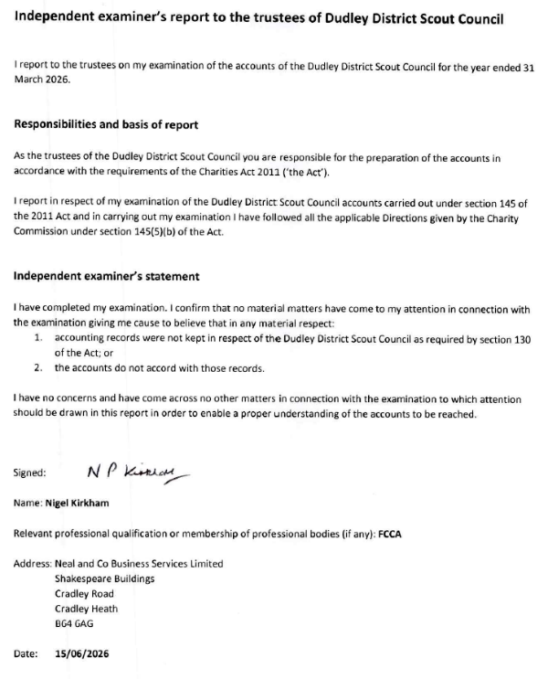
Awards 2026
Commissioner Commendation - Michelle Holding
Commissioner Commendation - Myla Haywood
Commissioner Commendation - Josh Markham
Commissioner Commendation - Anthony Mullen
Commissioner Commendation - Matt Williams
Commissioner Commendation - Adrian Pargeter
Commissioner Commendation - Ed Godwin
Commissioner Commendation - Imogen Smith
Commissioner Commendation - Kathryn Shepherd
Commissioner Commendation - Ann Hartmann
Commissioner Commendation - Tom Bridgwater
Commissioner Commendation - Anoop Dattani
Commissioner Commendation - Stephen Morton
Commissioner Commendation - Annette Doherty
Commissioner Commendation - Jon Shuard
Commissioner Commendation - Karen Stevens
Commissioner Commendation - Jonathan Hadley
Commissioner Commendation - Gary Walker
Commissioner Commendation - Anna Rock
Commissioner Commendation - Esther Haywood
Commissioner Commendation - Brandon Cooper
Commissioner Commendation - Richard Brant

Chief Scout's Commendation for Good Service
Christopher Noel Robert Soper Dudley
Jon Whitehouse Dudley - Dudley District Explorers
Rhiannon Eleanor Jayne Beach 2nd Wordsley (Holy Trinity)
Kerry Bullock Dudley

Award for Merit
Alison June Whitehouse Dudley - Dudley District Explorers
Frances Anne Mary Sedgley Dudley
George James Whitehouse Dudley - Dudley District Explorers
Ian James Whitehouse Dudley - Dudley District Explorers
James Douglas Roger McEwan Dudley - Dudley District Explorers
David Callum Chadwick Dudley
Luke David Steventon Dudley - Dudley District Explorers
Mark Anthony Beatrup Dudley
Neill Christopher Moran 1QB
Nils Wyldbore Dudley - Dudley District Explorers
Peter Charles Stevens Dudley
Rachel Louise Wilson Dudley
Samuel James Beach Dudley
Jamie Beese Raybould Dudley
Tracey Jones 1QB
Richard Smirthwaite Dudley
Chris Haywood Dudley
Guy Sheppard Dudley

Bar To The Award for Merit
Dawn Rides 1K

Silver Acorn
David Richard Tyler Dudley
Paul Parsons Dudley
Michael Leedham 1st Netherton

Length of Service:
5 years Length of Service - Lucas Robinson
5 years Length of Service - Ross Williamson
5 years Length of Service - Samantha Louise Pinchers
5 years Length of Service - Thomas Bridgwater
5 years Length of Service - Joanna Bennett
5 years Length of Service - Julie Fellows
10 years Length of Service - Paul Todd
10 years Length of Service - Kerry Fellows
10 years Length of Service - Karen Stevens
10 years Length of Service - Jordan Leigh Woodhouse
15 years Length of Service - Claire Handford
15 Years Length of Service - Jonathan Hadley
20 Years Length of Service - Robert Fellows
20 years Length of Service - Jamie Beese-Raybould
20 years Length of Service - Rebecca Louise Weaver
20 years Length of Service – Christopher St John Haywood
25 years Length of Service - Mathew John Fellows
30 years Length of Service - Richard Powell
40 years Length of Service - John Pearsall
40 years Length of Service - Suzanne Slimm
40 years Length of Service - Wendy Everall

Declaration

The trustees declare that they have approved the trustees’ report above.
Signed on behalf of the charity’s trustees by:

Signature

Full name | Kerry Bullock | Ted Batham
Position held | Chair | Trustee / District Lead Volunteer
Date | 04/07/2026 | 04/07/2026

